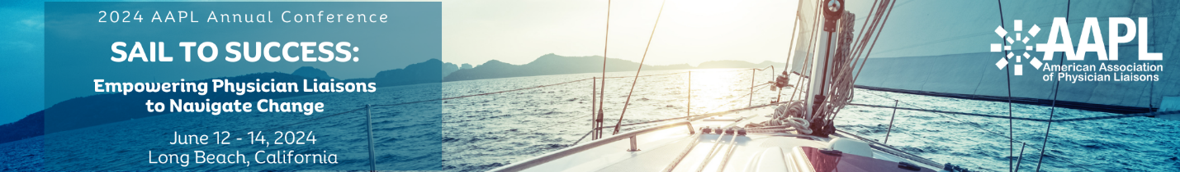

Dear [Supervisor’s Name],
I would like to request your support and permission to attend the American Association of Physician Liaisons Annual Conference which will take place from June 12-14, 2024, at the Renaissance Hotel in Long Beach, California. This conference presents a valuable opportunity for me to enhance my professional skills and knowledge, which will ultimately benefit our team and [organization].
The American Association of Physician Liaisons [AAPL] is renowned for its unique educational offerings and networking opportunities, and it attracts a diverse group of professionals from our industry.
The conference will feature presentations and workshops by industry experts on the latest trends, best practices, and innovative strategies in our field. This knowledge can help us stay competitive and adaptable in our rapidly evolving industry.
I kindly request your support in terms of time off, financial assistance, and any other resources necessary to make my attendance at the AAPL 2024 Annual Conference possible. The opportunity for me to learn, enhance my competencies, and establish connections with other physician liaisons makes my attendance at the 2024 AAPL Annual Conference a very wise investment and will be mutually beneficial for both my professional growth and [our organization]'s continued success.
Thank you for considering my request.
Sincerely,
[Your Name]

